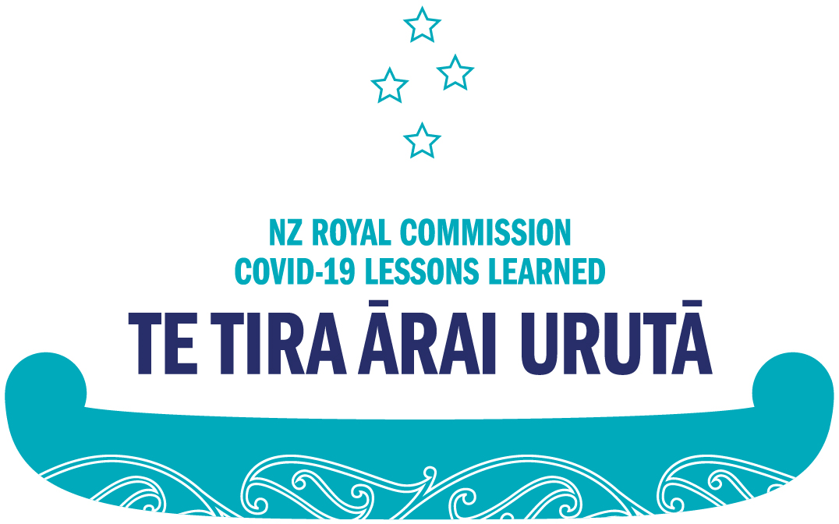

Making a submission to the Royal Commission of Inquiry into COVID-19 Lessons Learned

What is the Royal Commission of Inquiry into COVID-19 Lessons Learned?
The Royal Commission of Inquiry into COVID-19 Lessons Learned was set up by the New Zealand government in 2022 to investigate Aotearoa New Zealand’s COVID-19 experience so the country can be more prepared for future pandemics.
Although the Commission was set up by the Government, it is important to know that the Commission is independent from the Government.
The Commission has studied the information available already, like research studies. We have also met with organisations that played an important role in the pandemic, like government organisations, businesses, education providers, and health providers.
The Commission would now like to hear from the public about their experiences during the COVID-19 pandemic and their thoughts on how future pandemics could be managed.
The final report from the Commission is due on 30 September 2024.

How do I tell the Commission about my experience?
You can tell the Commission about your experience by making a public submission.
When you make a public submission you will be asked two questions. The questions are:
1. Looking back – what would you like the Inquiry to know about your experiences of the pandemic?
2. Moving forward – what lessons should we learn from your experiences so we can be as prepared as possible for future pandemics?
You can answer both questions or you can just answer one question.

New Zealand Sign Language users
If you use New Zealand Sign Language, you can make a video-recorded submission which will then be translated into New Zealand English.
When you click on the New Zealand Sign Language submission form you will be able to record your answers to both questions and provide demographic information on video.
Your video submission will be recorded using the camera on your device through the Videomail service. When you click the ‘Send Videomail’ button, your video will then be emailed to the Commission. The email address of the Commission will be autofilled in the form.
Once the Commission receives your video submission, we will download all submissions. Your submission will then be translated into New Zealand English.
Once the Commission receives the translated submissions, they will be entered into our system to be analysed along with submissions received in all other languages.

Answering the first question
The first question asks about your experience during the COVID-19 pandemic in Aotearoa New Zealand.
Please tell us how the pandemic impacted your life. You could talk about how the pandemic changed your education, your health, your relationships, or your work. You can also tell us anything else that changed in your life.
You can include changes that were good and changes that were difficult.

Answering the second question
The second question asks you how Aotearoa New Zealand should get prepared for a future pandemic.
When you answer this question, please tell us what you would like Aotearoa New Zealand to do during another pandemic and why you would like that to happen.
You can talk about things you would like to stay the same and things you would like to change.

Making my submission
You can make your submission by filling in the online submission form.
To fill in the form, please visit www.covid19inquiry.nz.
When you get to that page, please click on the form you would like to use. We have forms available in English, te reo Māori, New Zealand Sign Language, Simplified Chinese, Hindi, Samoan, and Tongan.
Once you click on the form, you will arrive on a page with the two questions where you can type your answers into the textbox. If you use the NZSL submission form you will click a button to submit your video response.
Once you have answered both questions you will be asked for some demographic information like your name, location, and ethnicity. You don’t have to answer these questions, but the answers will help the Commission give better recommendations to the Government in our final report.
Submissions close on 24 March 2024.

Help making a submission
If you need help making a submission, please use the link below.
This link will automatically create an email to our team asking for help with your submission. Once you click “Send”, you will receive a reply with information on further support available.
I need help with my submission
(InquiryintoCOVID-19lessons@dia.govt.nz)
End of information: Making a submission to the Royal Commission of Inquiry into COVID-19 Lessons Learned
This Large Print document is adapted by Blind Citizens NZ from the standard document provided by the Royal Commission of Inquiry into COVID-19 Lessons Learned

