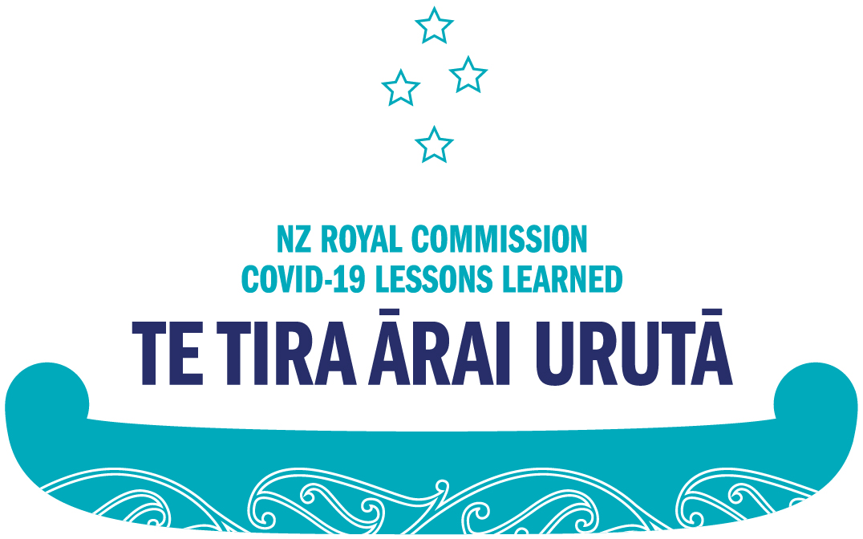

Providing feedback on the terms of reference for the Royal Commission of Inquiry into COVID-19 Lessons Learned

What is the Royal Commission of Inquiry into COVID-19 Lessons Learned?
The Royal Commission of Inquiry into COVID-19 Lessons Learned was announced by the New Zealand Government in December 2022 to investigate Aotearoa New Zealand’s COVID-19 experience so the country can be more prepared for future pandemics.
The Commission is investigating the COVID-19 pandemic experience by studying available information, meeting with individuals, organisations and communities that played an important role in the pandemic, and asking the public to share their experiences.
The final report from the Commission is due on 30 September 2024.

What are the terms of reference?
The terms of reference explain the purpose and scope of the Inquiry. They set out what areas of the COVID-19 pandemic the Royal Commission can and can’t investigate, as well as things like the Inquiry’s purpose and the approach it should take.
The terms of reference are set by the Government, and the Government may change the terms of reference.

Summary of the terms of reference
The Inquiry is currently tasked with looking at how to strengthen Aotearoa New Zealand’s preparedness for future pandemics. It will do this by identifying what lessons can be learned from New Zealand’s response to COVID-19, and how those lessons could be applied in preparation for any future pandemic.
The current scope of the Inquiry includes looking at and considering for the future:
- The public health response and delivery of health services – this includes things like border closures and MIQ arrangements; the approval of and mandating of vaccines; lockdowns and isolation arrangements; as well as vaccine passes, gathering limits, and personal protective equipment (or PPE).
- The provision of goods and services – this includes things like how people’s everyday needs were met during the pandemic, such as the provision of lifeline utilities and services, e.g. water and electricity; how education and childcare services were delivered; and other essential services that the Government provides, like regular superannuation payments or housing.
- The economic response – this includes things like how support to individuals and businesses was provided, like the wage subsidy, for example; exemptions that were put in place for specific industries like farming, for example; and the Government’s economic response more generally.
- Government communication, engagement, and decision-making – this includes things like how people and communities were communicated and engaged with during the pandemic, in order to limit the spread of the virus and ensure people were kept safe, and what sort of decision-making structures and arrangements might be used or put in place during a pandemic that continues for a long time.
The Inquiry is also tasked with looking at what kinds of legislative and policy settings and delivery approaches could improve New Zealand’s preparedness and response to a future pandemic.
The Inquiry is also considering the interests of Māori in the context of the pandemic, consistent with Te Tiriti o Waitangi relationships.
The Inquiry is also looking at how to best support the wellbeing of essential workers (people working in supermarkets or at the border, for example), and communities and population groups (Māori and Pasifika, for example) who are likely to be most impacted by a pandemic.

Limits to the Inquiry’s scope
While the Inquiry will look at many aspects of the pandemic response, currently, there are a number of topics outside the Inquiry’s scope. These include:
- Particular clinical decisions made by clinicians or by public health authorities during the pandemic;
- How and when the strategies and other measures devised in response to COVID-19 were implemented or applied in particular situations or in individual cases;
- The specific epidemiology of the COVID-19 virus and its variants;
- Vaccine efficacy;
- Recent reforms to New Zealand’s health system, including the organisational arrangements for public health services;
- The judgments and decisions of courts and tribunals and independent agencies such as the Ombudsman, the Privacy Commissioner, or the Independent Police Conduct Authority relating to the pandemic;
- The operation of the private sector, except where the private sector delivers services integral to a pandemic response;
- Particular decisions taken by the Reserve Bank’s independent monetary policy committee during the pandemic;
- Any adaptation of court procedures by the judiciary during the pandemic;
- Any adaptation of parliamentary processes during the pandemic;
- The conduct of the general election during the pandemic.

You can read the whole terms of reference at https://www.legislation.govt.nz/regulation/public/2022/0323/latest/LMS792965.html (or http://tinyurl.com/2dfc2yjz)

Why are the terms of reference being reviewed?
The Government is committed to expanding the scope of the terms of reference. It has asked the Royal Commission to consult with the New Zealand public, on its behalf, to get feedback on this expansion of the terms of reference.
While the Inquiry is looking at a wide range of topics related to the COVID-19 pandemic, such as mandates and other public health measures, we recognise there may be other specific topics that people would like considered and which could be included, or clarified, in the terms of reference. The Government has proposed a range of topics and would like your feedback on their inclusion.
Information gathered through this public consultation will be provided to the Department of Internal Affairs, who will then provide advice to the Government ahead of any changes to the Inquiry’s terms of reference. Your response will be subject to the Official Information Act and the Privacy Act. The Department of Internal Affairs may publish a report or analysis of the feedback received.
As a result of this consultation, the Royal Commission may be asked to look at additional aspects of the COVID-19 response.

How do I share my feedback on the terms of reference?
The Commission wants to know your thoughts about the terms of reference for the Inquiry.
You can share your feedback on the terms of reference for the Inquiry by filling in the ‘Feedback on our Terms of Reference’ form at www.covid19inquiry.nz
You will be asked:
The coalition Government is committed to expanding the scope of the Royal Commission of Inquiry into COVID-19 Lessons Learned based on public input, by adding additional topics to the terms of reference. Do you have specific feedback on the inclusion of these topics into the terms of reference?
- Use of multiple lockdowns;
- Vaccine procurement and efficacy;
- The social and economic impacts on both regional and national levels;
- Whether the decisions made, and steps taken, were justified;
- The cost-effectiveness of the Government’s policies, and whether the rules set by the Government appropriately balanced COVID-19 elimination with other goals;
- The Government’s utilisation of partnerships with business and professional groups;
- The extent of disruption to New Zealanders’ health, education and business as a result of the Government’s policies;
- If the Government’s response was consistent with the rule of law;
- How New Zealand’s pandemic preparedness compared to other countries.

You can also share your experiences from the COVID-19 pandemic with the Commission by filling in the ‘Share your story’ form at www.covid19inquiry.nz

New Zealand Sign Language users
If you use New Zealand Sign Language, you can provide your feedback via video-recording.
When you click on the New Zealand Sign Language feedback form you will be able to record your answer on video.
Your video will be recorded using the camera on your device through the Videomail service. When you click the ‘Send Videomail’ button, your video will then be emailed to the Commission. The email address of the Royal Commission will be automatically filled into the form.
Once the Royal Commission receives your video it will be translated into New Zealand English.

What will happen after I share my feedback on the terms of reference?
Your feedback will be sent to the Department of Internal Affairs. The New Zealand Government will use all the feedback provided to decide what changes to make to the Commission’s terms of reference.
If changes are made to the terms of reference, the Commission will need to do further investigations to make sure we have covered all the topics in the terms of reference. The Commission may do this in a range of ways.

Providing feedback about the terms of reference
You can provide your feedback by filling in the ‘Feedback on our Terms of Reference’ form at www.covid19inquiry.nz
When you get to that page, please click on the form you would like to use. There are forms available in English, te reo Māori, New Zealand Sign Language, Simplified Chinese, Hindi, Samoan, and Tongan.
Once you click on the form, you will arrive on a page where you can type your answer to the question into the textbox. If you use the NZSL submission form you will click a button to submit your video response.
Once you have answered both questions you will be asked for some demographic information like your name, location, and ethnicity. You don’t have to answer these questions, but the answers will help the Government better understand who is providing feedback on the terms of reference.
Submissions about the terms of reference close on 24 March 2024.

Help making a submission
If you need help providing your feedback about the terms of reference, please Email
InquiryintoCOVID-19Lessons@dia.govt.nz with ‘I need help with my submission’ in the subject line.
Once you click “Send”, you will receive a reply with information on further support available.

End of information: Providing feedback on the terms of reference for the Royal Commission of Inquiry into COVID-19 Lessons Learned

This Large Print document is adapted by Blind Citizens NZ from the standard document provided by the Royal Commission of Inquiry into COVID-19 Lessons Learned

