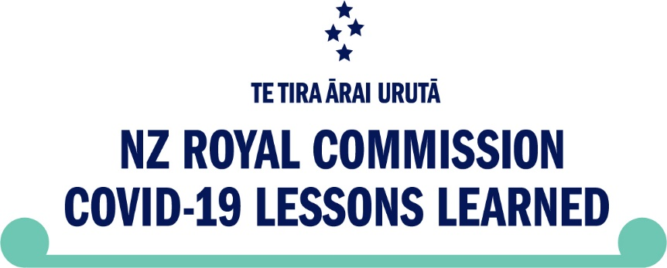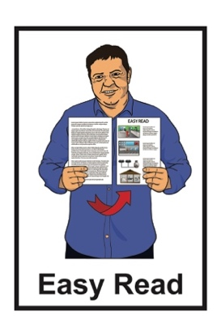

COVID-19 Inquiry Phase 2   
Public Submissions

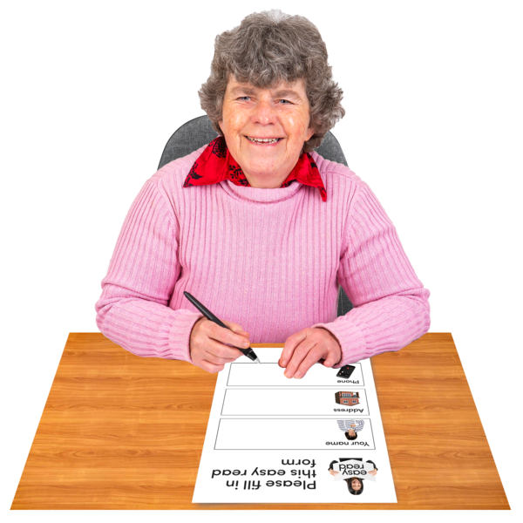

Published: March 2025

# About this document

****This Easy Read document is from the **New Zealand Royal Commission of Inquiry into COVID-19 Lessons Learned – Te Tira Ārai Urutā.**

In this document:

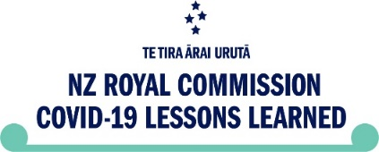the New Zealand Royal Commission of Inquiry into COVID-19 Lessons Learned – Te Tira Ārai Urutā will be called **the Inquiry**

the words **we / us** mean the Inquiry.

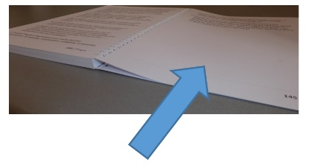There is more information about the Inquiry on page 3.

**COVID-19** is a type of virus that makes people sick.

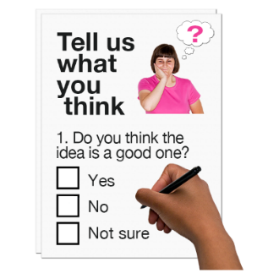

We want to hear from people about their **experience** during the   
COVID-19 **pandemic**.

**Experience** means what you went through.

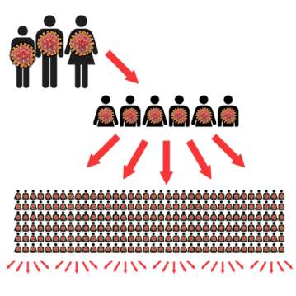

A **pandemic** is when people around the world get the same sickness at the same time.



Pages 12 to 15 show how you can tell us about your experiences.

# What is the New Zealand Royal Commission COVID-19 Lessons Learned – Te Tira Ārai Urutā?

The Inquiry website can be found here:

[**tinyurl.com/2hhm88kw**](https://tinyurl.com/2hhm88kw)

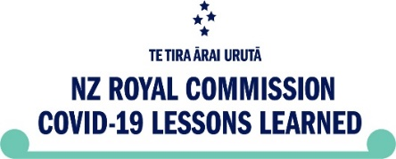

The Inquiry is done by the Royal Commission.

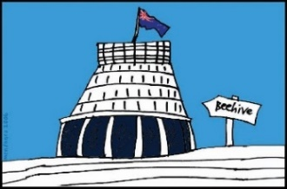

The Royal Commission is **not** part of the Government.

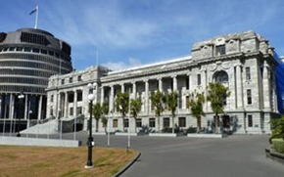The Inquiry was set up:

by the New Zealand Government in 2022

to **review** the experiences people had of the COVID-19 pandemicin Aotearoa New Zealand.

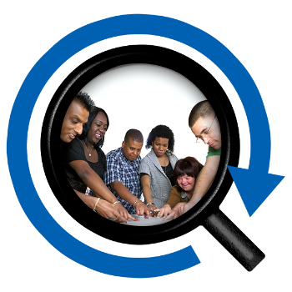A **review** means looking at something so people know:

how it happened

what people did to deal with it

what to do if it happens again.

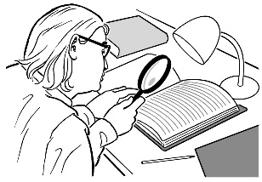To review how Aotearoa New Zealand handled the COVID-19 pandemic the Inquiry uses:

publicly available information like research papers

**evidence** from people who made important decisions like former Prime Minister Jacinda Ardern

* 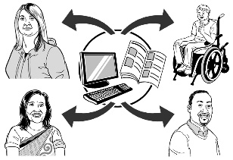information from people who were affected by the response Aotearoa New Zealand had to the pandemic.

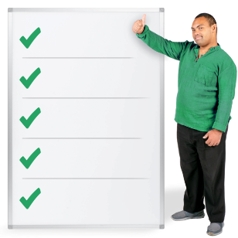

**Evidence** is facts about something that happened.

The Inquiry then makes **recommendations** to the Government on how Aotearoa   
New Zealand can better:

* 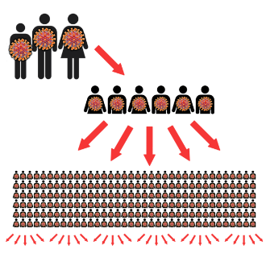prepare for a future pandemic
* respond to a future pandemic.

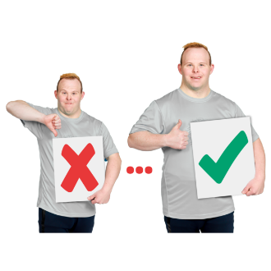

Here **recommendations** are suggestions on how to do something better.

We have already spent 2 years reviewing how Aotearoa New Zealand responded to the COVID-19 pandemic.

At the end of 2024 the Inquiry was asked to:

* review some new **topics**
* look at some of the topics we were already looking at in more detail.



**Topics** are the areas / things the Inquiry is reviewing.

The rest of this document will go through:

* the topics we are reviewing now
* 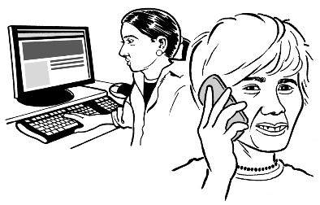how you can tell us about your experiences on these topics.

# The topics we are currently reviewing



The Inquiry is currently looking at **key decisions** made by the Government during:

* 2021

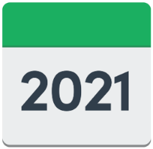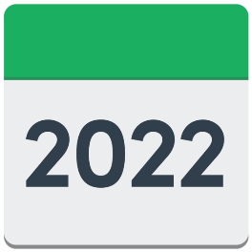

* 2022.

Here a **key decision** is a decision Government made that:

* 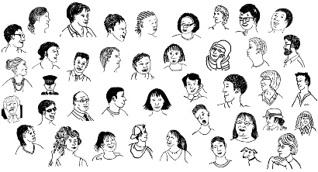affected a lot of people
* cost a lot of money at:
* 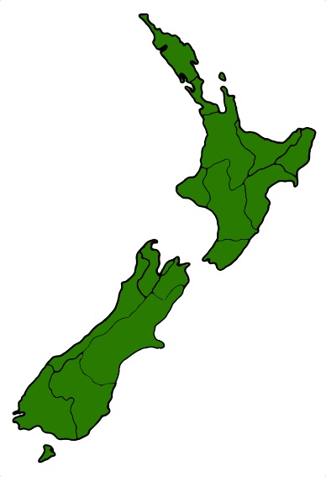a regional level like Auckland
* a national level which means the whole country
* both levels.

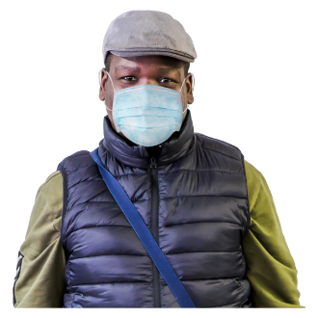The topics are:

* public health materials like masks

**vaccine** safety

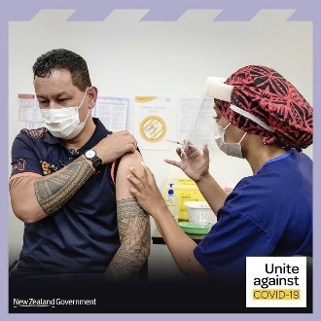approval for COVID-19 vaccines

**vaccine mandates**

* **contact tracing**
* **lockdowns** especially the:
* nationallockdown in 2021
* 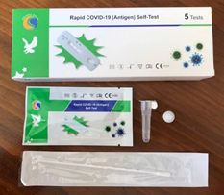Auckland / Northland lockdowns in 2021 – 2022

COVID-19 testing.

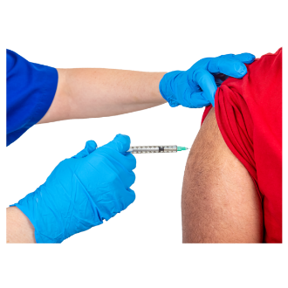A **vaccine** is a medicine that can help stop you from getting very sick.

**Vaccine mandates** were rules that said some people like doctors had to have vaccines to keep doing their jobs.

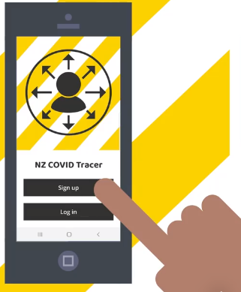

**Contact tracing** means listing:

* where you have been
* the people you have spent time with.

**Lockdowns** were when the Government asked everyone to stay at home so they would not:

* get sick
* spread COVID-19 to other people.



The Inquiry will:

review the key decisions made by the Government in these areas / topics

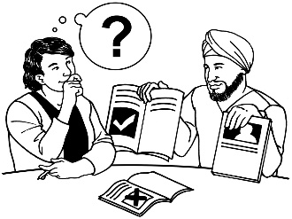give recommendations on how Aotearoa New Zealand could:

* make better decisions if a pandemic happens again in the future
* be better prepared if a pandemic happens again.

# How you can tell us about your experience

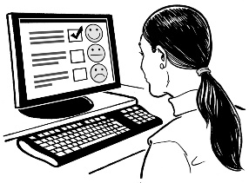You can tell us about your experience in 2 ways:

* fill in an online form
* 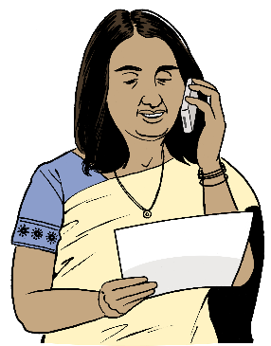call the call centre staff to tell them your experience.

You can tell us about your experience until **midnight** on   
**27 April 2025.**

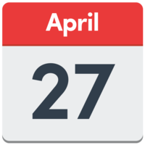

The online form is available at this website:

[**tinyurl.com/yhjnr8ts**](https://tinyurl.com/yhjnr8ts)

Follow the instructions on the form.

Most screen readers will work on the website.

For support please contact us by:

* **phone** on:  
    
  **0800 500 306**
* **email** on:

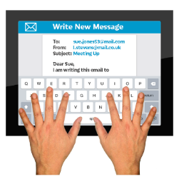

[**InquiryintoCOVID-19lessons@dia.govt.nz**](mailto:InquiryintoCOVID-19lessons@dia.govt.nz)



The call centre staff can also record your experience over the phone.

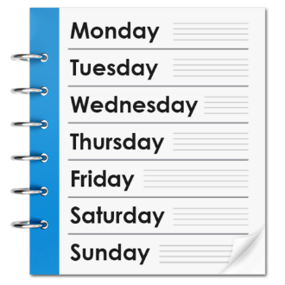

The call centre is open:

* Monday to Friday
* 10 am to 7 pm.

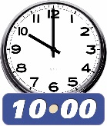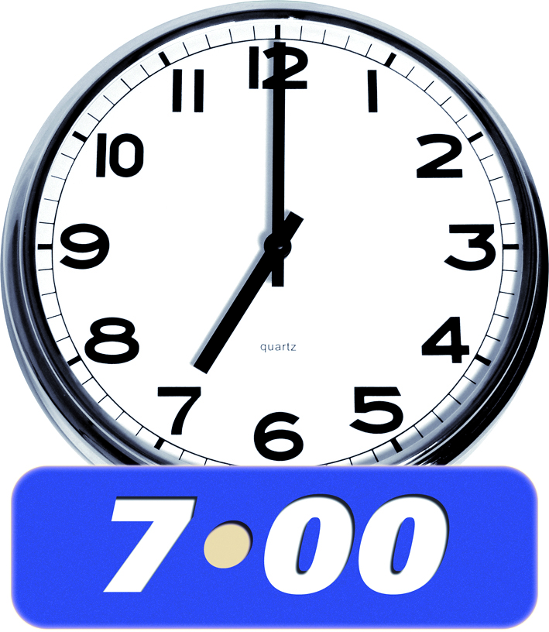

If you find it hard to use the phone the **New Zealand Relay** service is for people who are:

* 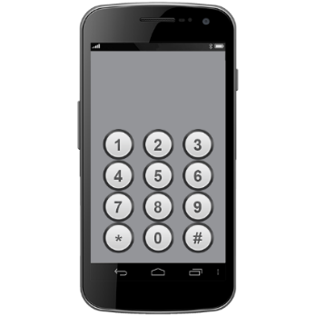Deaf / hard of hearing
* deafblind
* speech impaired / find it hard to talk.

You can find out more about the New Zealand Relay service at:

[**www.nzrelay.co.nz**](http://www.nzrelay.co.nz)

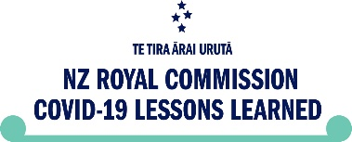This information has been written by the Royal Commission of Inquiry into COVID-19.

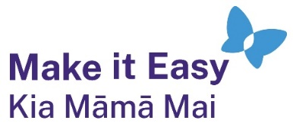It has been translated into Easy Read by the Make it Easy Kia Māmā Mai service of People First New Zealand Ngā Tāngata Tuatahi.



The ideas in this document are not the ideas of People First New Zealand Ngā Tāngata Tuatahi.



All images used in this Easy Read document are subject to copyright rules and cannot be used without permission.

Make it Easy uses images from:

* Photosymbols
* Change Images
* Huriana Kopeke-Te Aho



* SGC Image Works
* T Wood
* A logo for a school

  Description automatically generatedStudio Rebeko
* Inga Kramer.