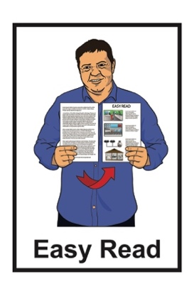
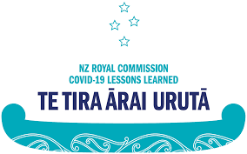

How to tell the

Royal Commission of Inquiry into COVID-19 Lessons Learned

what COVID-19 was like for you
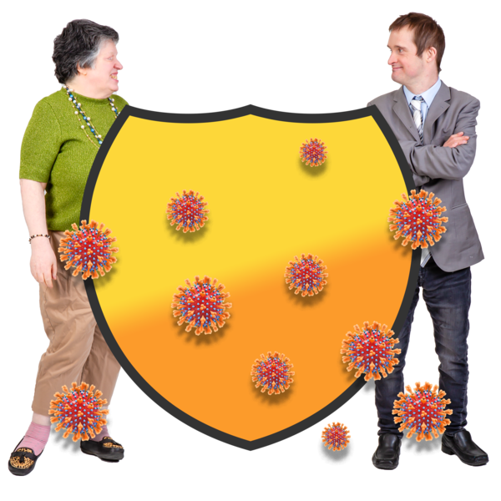

Published: November 2023

What this document is about

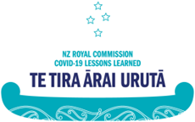
This Easy Read document is about the Royal Commission of Inquiry into COVID-19 Lessons Learned – Te Tira Ārai Urutā.

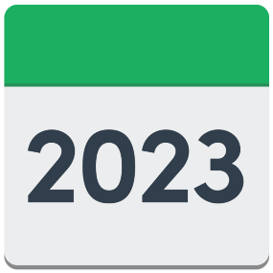
Royal Commission of Inquiry into COVID-19 Lessons Learned – Te Tira Ārai Urutā started work in 2023.

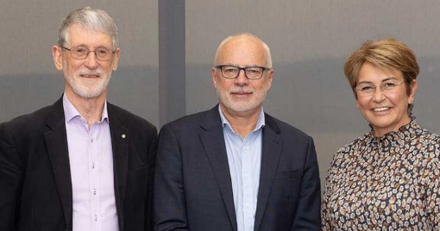
It is a group of people learning about things that happened during the COVID-19 pandemic.

In this document Royal Commission of Inquiry into COVID-19 Lessons Learned – Te Tira Ārai Urutā will be called the Royal Commission.
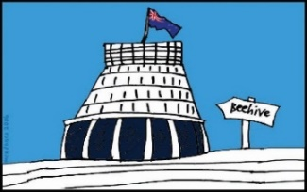
The Royal Commission is not part of the Government.

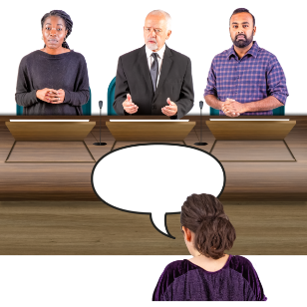
The Government can ask the Royal Commission what to look for.

The Government cannot tell the Royal Commission what should go into their report.
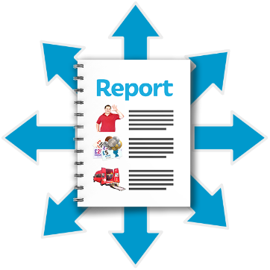

As part of their work the Royal Commission will tell the Government what they find out.

You can find more information about the Royal Commission at this website:

www.covid19lessons.royalcommission.nz
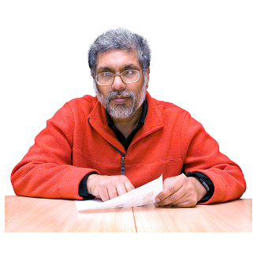
The Royal Commission is asking for submissions to the Inquiry into COVID-19 Lessons Learned.

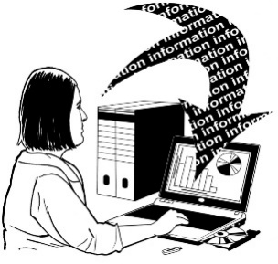
A submission is when you tell people what you think about things.

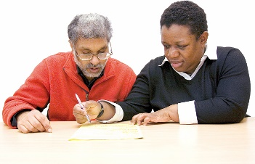
This document will tell you how to make a submission to the Royal Commission.

What is the COVID-19 pandemic?

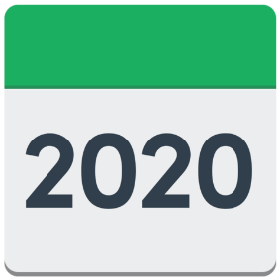
The COVID-19 pandemic started in Aotearoa New Zealand in 2020.

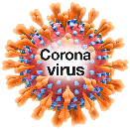
COVID-19 is a type of virus that makes people sick.

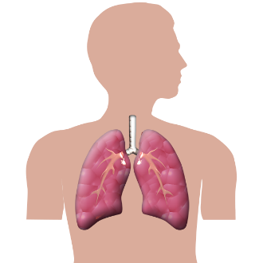
COVID-19 can affect your:

- lungs

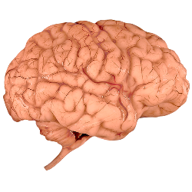
- airways

- other organs / parts of your body.
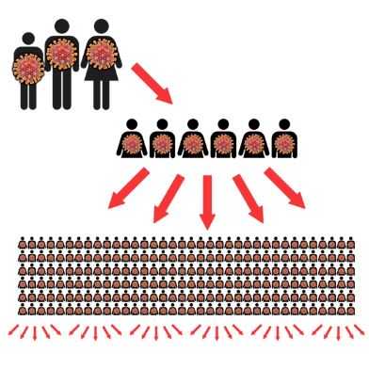

A pandemic is when many people around the world get the same sickness at the same time.
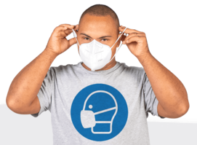
There were lots of rules to follow during the COVID-19 pandemic like:
lockdown
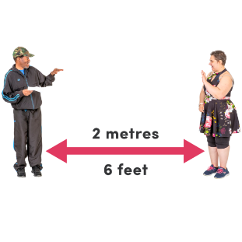
wearing masks
keeping a distance from people
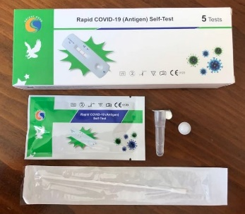
staying at home when sick
taking tests
getting the the COVID-19 vaccine.
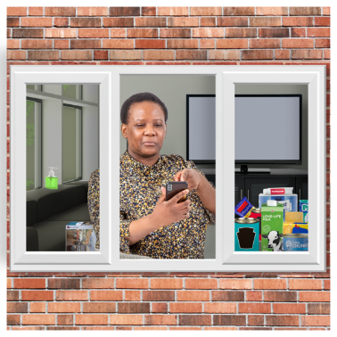

Lockdown was when the Government asked everyone to stay at home so that they did not get sick.

A vaccine is a medicine that can help stop you from getting very sick.

What does the Royal Commission
want to know?

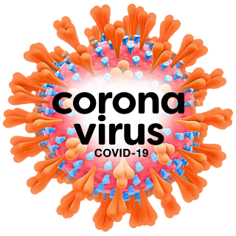
The Royal Commission wants to know what people think about what happened during the COVID-19 pandemic.

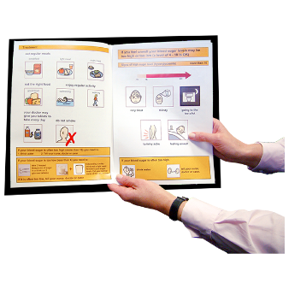
The Royal Commission wants this information so they can be ready for other pandemics that might happen.

The Royal Commission has already looked at information from:
research studies
government organisations
business.

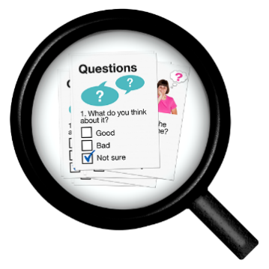
Research studies are where people spend time collecting information about new things.

The Royal Commission has also talked to people in:
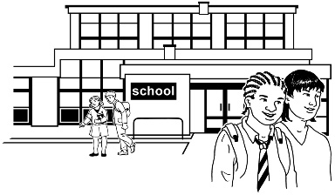
education like:
- schools
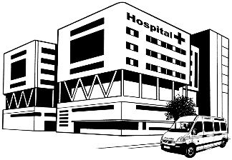
- universities
health
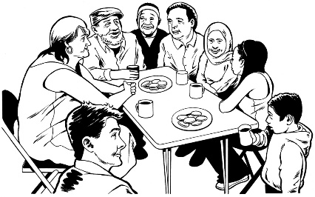
different public organisations
community groups.

The Royal Commission now wants to know:
what happened to you during the COVID-19 pandemic
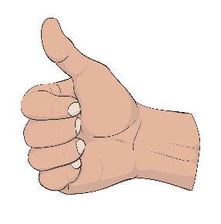
what you think could be done better if other pandemics happen.

How to make a submission

You can tell the Royal Commission what you think by making a public submission.

You can do this at this website:

www.Covid19Inquiry.nz

Choose the submission form you want on that website.
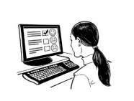

You can type your answers into the textbox.

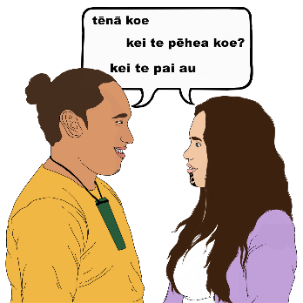
The submission form is available in:
English
Māori
New Zealand Sign Language
Simplified Chinese
Hindi
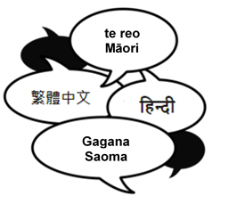
Samoan
Tongan.

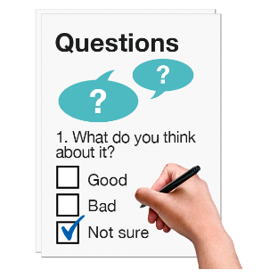
There are 2 questions for you to answer on the submission form.

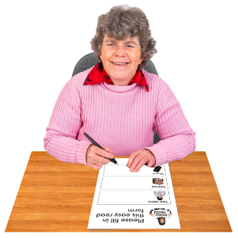
You will also be asked to give information about who you are.

This will let the Royal Commission give better information to the Government.

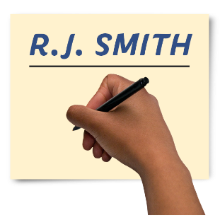
You will be asked things like:
your name
where you live
your ethnicity.

Ethnicity means your:
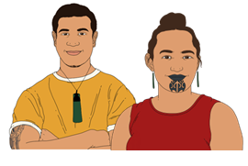
race like:
- Māori
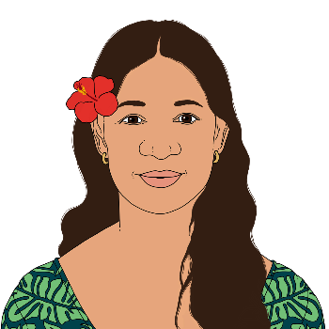
- Samoan
- New Zealand European
background like whether you:
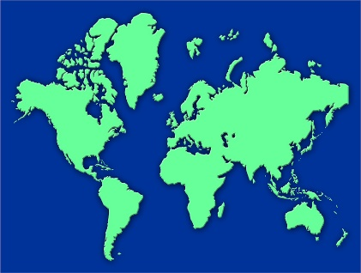
- were born in Aotearoa New Zealand
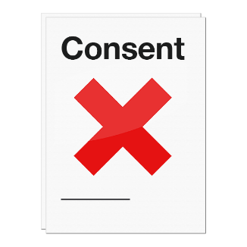
- moved to Aotearoa New Zealand from another country.

You do not have to give this information about yourself.
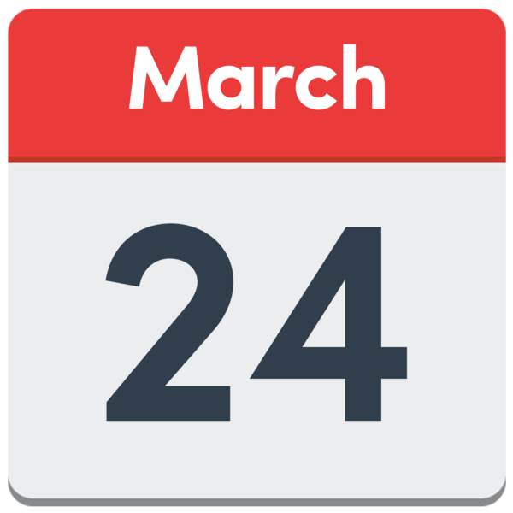
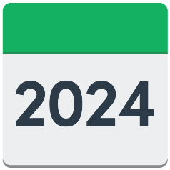
The last day to make a submission is 24 March 2024.

How to make a submission using NZSL

You can make your submission on the website using New Zealand Sign Language.

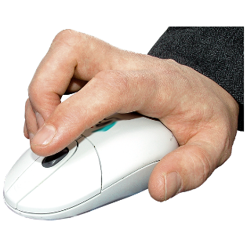
Choose the form that says New Zealand Sign Language.

You will need to click a button to record a video of your answers.

When you finish your video it will be emailed to the Royal Commission.

What are the questions?

There are 2 questions for you to answer.

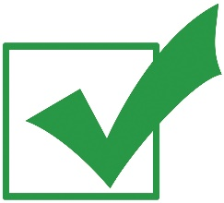
You can answer:
1 question
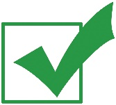
or
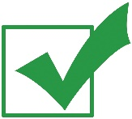
both questions.

Looking back
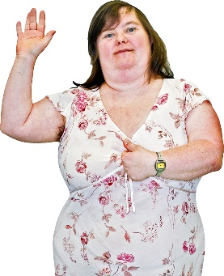
The first question asks you to talk about what happened to you during the COVID-19 pandemic.

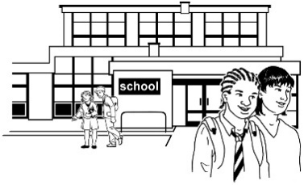
You can talk about the things that changed in your life like:
education like:
- school
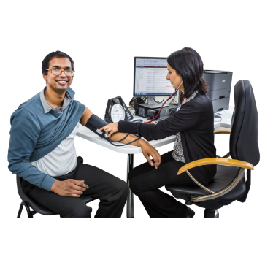
- university
health
work
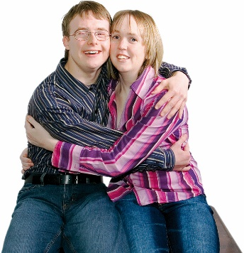
relationships
anything else.

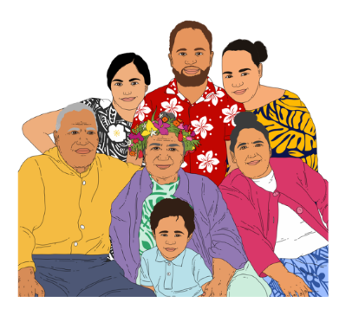
Relationships means how you get on with:
your family / whānau
your partner
your friends
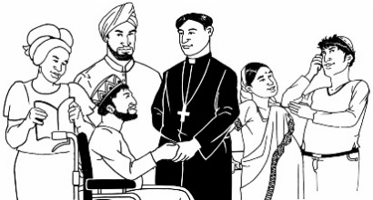
your neighbours
people in your religious group like at church
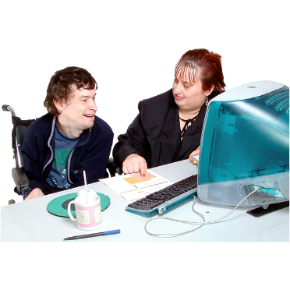
people in your community
people you work with.

You can talk about changes that were:
good
bad.

Moving forward
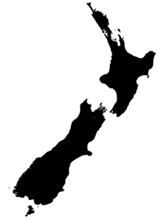
The second question asks you to talk about how Aotearoa New Zealand should get ready for a pandemic that might happen in the future.

The future is a time that has not happened yet.

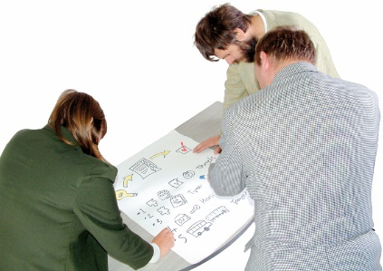
You can talk about:
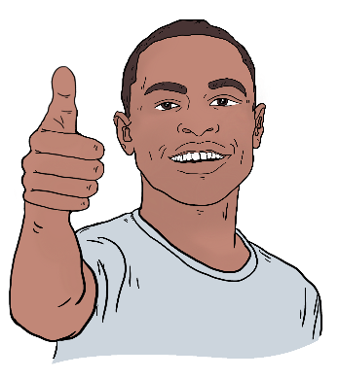
what you would like Aotearoa New Zealand to do if another pandemic happens
why you would like that to happen.

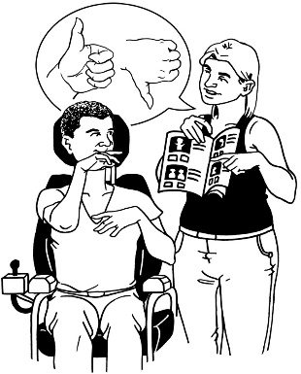
You can talk about the things you would like to:
be done the same way
be done differently.

How to get support with your submission

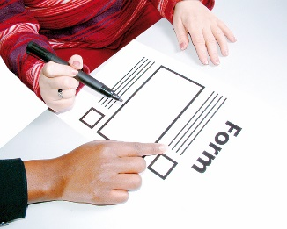
You can ask for support to make your submission.

You can send an email to:

inquiryintocovid-19lessons@dia.govt.nz

In the subject line of your email put:
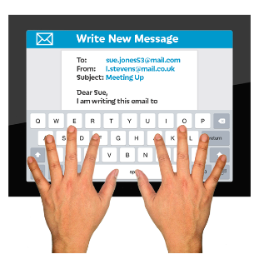
I need help with my submission.

You do not need to type anything else in your email.

Click send when you are done.

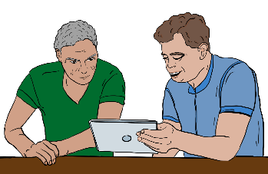
You will get an email with information on how to get support.

This information has been written by the Royal Commission of Inquiry into COVID-19 Lessons Learned.

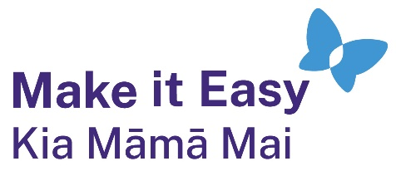
It has been translated into Easy Read by the Make it Easy Kia Māmā Mai service of People First New Zealand Ngā Tāngata Tuatahi.
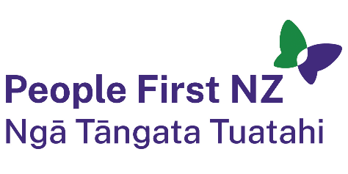
The ideas in this document are not the ideas of People First New Zealand Ngā Tāngata Tuatahi.
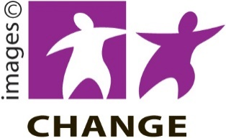
Make it Easy uses images from:

- Changepeople.org

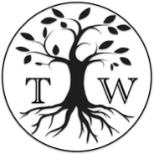
            - Photosymbols.com

- SGC Image Works
- Huriana Kopeke-Te Aho
- T. Wood.
All images used in this Easy Read document are subject to copyright rules and cannot be used without permission.

